**WEB TECHNOLOGY PROJECT**

Report submitted in partial fulfillment of the requirements for the award of

**Degree of Bachelor of Technology**

**in**

**Computer Engineering (COE)**

By:

**Rohit Sharma(2K13/CO/103)**

**Shamit Lal (2K13/CO/118)**

**Shivam Duggal (2K13/CO/121)**

To**:**



**Department of Computer Science and Engineering**

**Delhi Technological University**

**(Formerly Delhi College of Engineering)**

**Abstract**

MedWorld is an online, healthcare media publishing company. We provide easy-to-read, in-depth, authoritative medical information for consumers via its robust, user-friendly, interactive website. Founded in 2016, MedWorld.com has had a highly accomplished, uniquely experienced team of qualified executives in the fields of medicine, healthcare, Internet technology, and business to bring you the most comprehensive, sought-after healthcare information anywhere

HTML, CSS and Javascript are used to implement the frontend of the project.

Backend has been implemented using Django.

**FRONTEND TECHNOLOGIES**

**HTML**

* **HyperText Markup Language**, commonly abbreviated as **HTML**, is the standard markup language used to create web pages. Along with CSS, and JavaScript, HTML is a cornerstone technology used to create web pages,as well as to create user interfaces for mobile and web applications. Web browsers can read HTML files and render them into visible or audible web pages. HTML describes the structure of a website semantically and, before the advent of Cascading Style Sheets (CSS), included cues for the presentation or appearance of the document (web page), making it a markup language, rather than a programming language.

**CSS**

* **Cascading Style Sheets** (**CSS**) is a style sheet language used for describing the presentation of a document written in a markup language. Although most often used to set the visual style of web pages and user interfaces written in HTML and XHTML, the language can also be applied to any XML document, including plain XML, and is applicable to rendering in speech, or on other media. Along with HTML and JavaScript, CSS is a cornerstone technology used by most websites to create visually engaging webpages, user interfaces for web applications, and user interfaces for many mobile applications. CSS is designed primarily to enable the separation of document content from document presentation, including aspects such as the layout, colors, and fonts. This separation can improve content accessibility, provide more flexibility and control in the specification of presentation characteristics, enable multiple HTML pages to share formatting by specifying the relevant CSS in a separate .css file, and reduce complexity and repetition in the structural content.

**Javascript**

* **JavaScript** is a high-level, dynamic, untyped, and interpreted programming language. It has been standardized in the ECMA Script language specification. Alongside HTML and CSS, it is one of the three core technologies of World Wide Web content production; the majority of websites employ it and it is supported by all modern Web browsers without plug-ins. JavaScript is prototype-based with first-class functions, making it a multi-paradigm language,
* supporting object-oriented, imperative, and functional programming styles. It has an API for working with text, arrays, dates and regular expressions, but does not include any I/O, such as networking, storage, or graphics facilities, relying for these upon the host environment in which it is embedded.Despite some naming, syntactic, and standard library similarities, JavaScript and Java are otherwise unrelated and have very different semantics. The syntax of JavaScript is actually derived from C, while the semantics and design are influenced by the Self and Scheme programming languages. JavaScript is also used in environments that are not Web-based, such as PDF documents, site-specific browsers, and desktop widgets. Newer and faster JavaScript virtual machines (VMs) and platforms built upon them have also increased the popularity of JavaScript for server-side Web applications. On the client side, JavaScript has been traditionally implemented as an interpreted language, but more recent browsers perform just-in-time compilation.

**Bootstrap**

* **Bootstrap** is a free and open-source front-end library for creating websites and web applications. It contains HTML- and CSS-based design templates fortypography, forms, buttons, navigation and other interface components, as well as optional JavaScript extensions. It aims to ease the development ofdynamic websites and web applications. Bootstrap is a front end web framework, that is, an interface for the user, unlike the server-side code which resides on the "back end" or server.

**BACKEND TECHNOLOGIES**

**DJANGO**

* **Django** is a free and open-source web framework, written in Python, which follows the model–view–controller (MVC) architectural pattern. It is maintained by the Django Software Foundation (DSF).Django's primary goal is to ease the creation of complex, database-driven websites. Django emphasizes reusability and "pluggability" of components, rapid development, and the principle of don't repeat yourself. Python is used throughout, even for settings files and data models. Django also provides an optional administrative create, read, update and delete interface that is generated dynamically throughintrospection and configured via admin models.Some well-known sites that use Django include Pinterest, Instagram, Mozilla,The Washington Times.

**Other Technologies/Libraries Used**

* **pyquery**:- pyquery is a library similar to jquery. It allows you to make jquery queries on xml documents.
* **Goose**:- Goose is a library that allows you to extract the main article text from any web page.

**ACKNOWLEDGEMENT**

Firstly, we express our heartiest gratitude towards the authorities who gave us a chance to explore the intricacies of various aspects of **Web Development.**

We are grateful to **Dr. O.P. Verma, HOD** (Department of Computer Science and Engineering), Delhi Technological University, Delhi and all other faculty members of our department for their astute guidance throughout the project.

We would also sincerely thank our esteemed professor, **Ms. Akshi Kumar**, who lent a huge helping hand in the process of making this project with her valuable guidance and blessings.

In the end, we would like to thank our families for their extended support throughout the project.

**Rohit Sharma**

**Shamit Lal**

**Shivam Duggal**

ii

**INDEX**

**(1) MEDWORLD HOME PAGE..........................................................7**

**(2) LOGIN PAGE...............................................................................9**

**(3) NEWS AND INFORMATION ......................................................10**

**(4) HEALTHCARE MARKETTING......................................................11**

**(5)** **HEALTHCARE MEDIA................................................................12**

**(6) A-Z Guide to disease................................................................13**

**(7) VIDEO CHAT PAGE...................................................................14**

**(8) ALLOPATHY PAGE....................................................................15**

**(9) AYURVEDA..............................................................................16**

**(10) HOMEOPATHY.......................................................................17**

**(11) ABOUT US..............................................................................18**

**" Health is like money , you don't know its value untill you loose it "**

**" Stay healthy "**

**PAGES OF MEDWORLD WEBSITE**

**MEDWORLD COVER PAGE**  
  
*“ We aren't those who can give you healthy lives , but we can definitely guide you to one . “*

This page

* introduces you to MedWorld , where all your health related queries have a solution :
* Provides latest and credible health information .
* Guides you to choose your own medication , be it Homeopathy , Allopathy or Ayurveda .

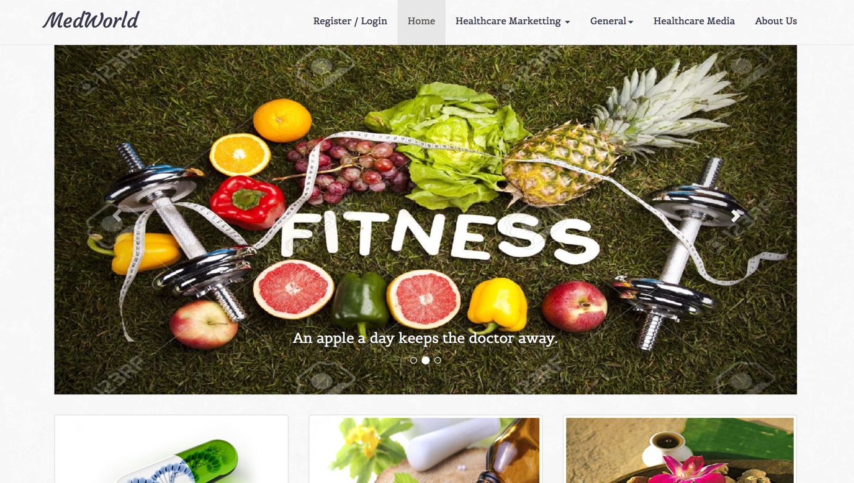

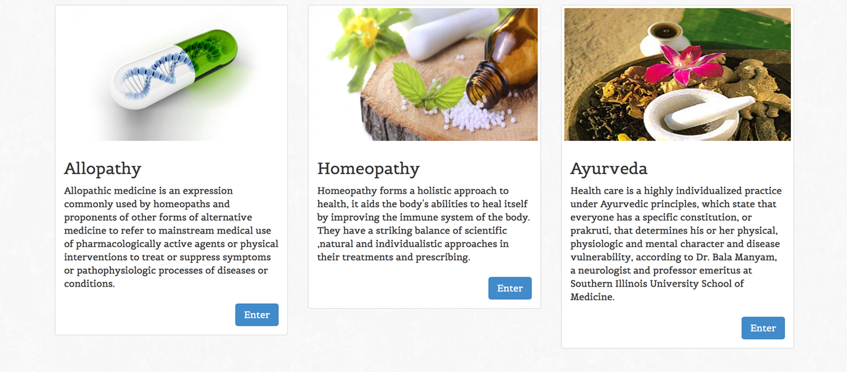

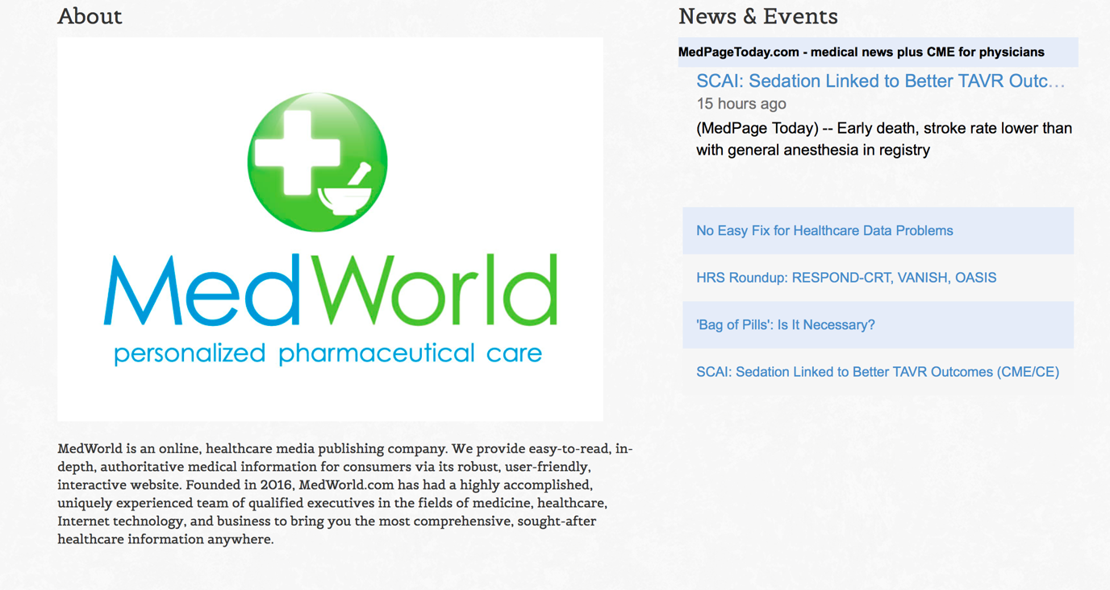

**LOGIN PAGE**

This page allows user to

* signup on medworld
* login on medworld

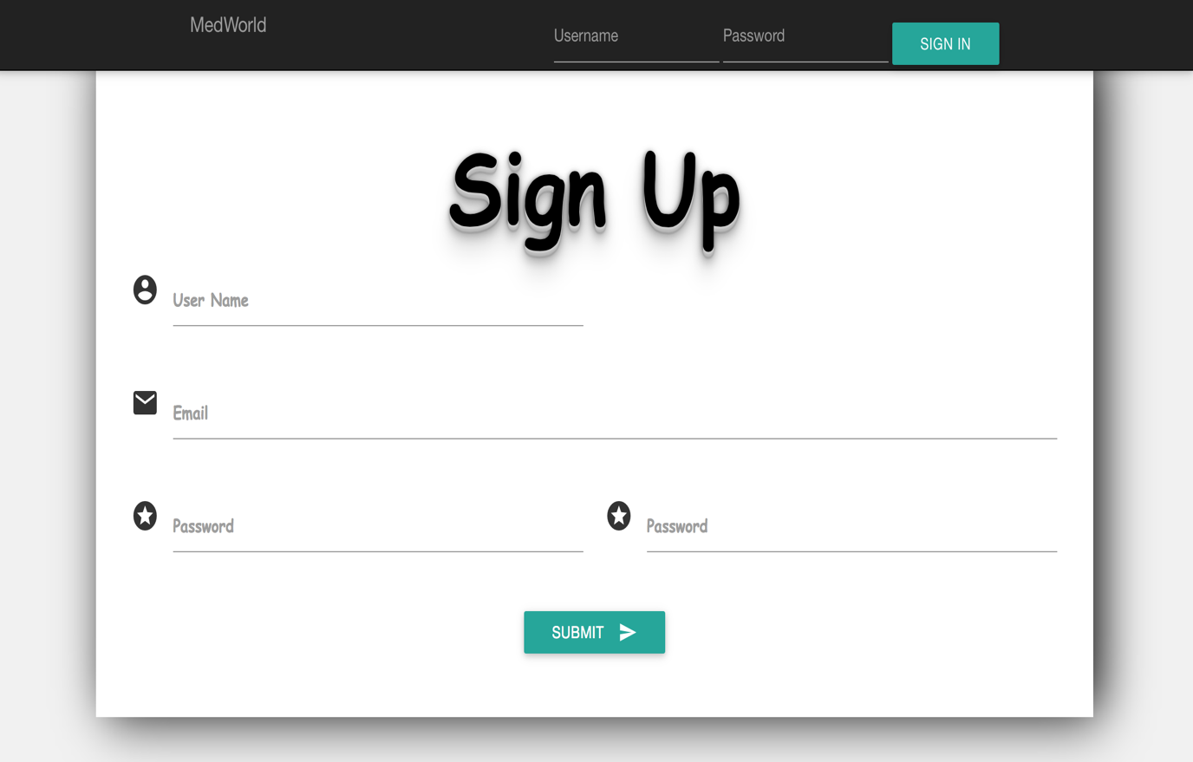

**NEWS AND INFORMATION**

This page

* Provides the viewers with the health news of the week . The news is dynamically crawled from trustworthy sources.
* Alerts the viewers with the viruses spread currently.
* Guides one with the healthy ways to live life.

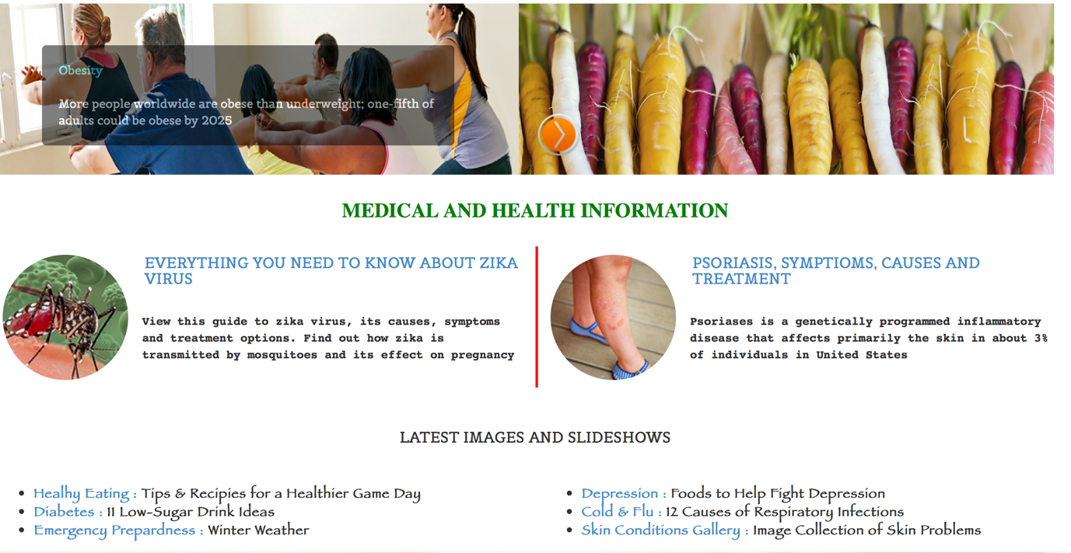

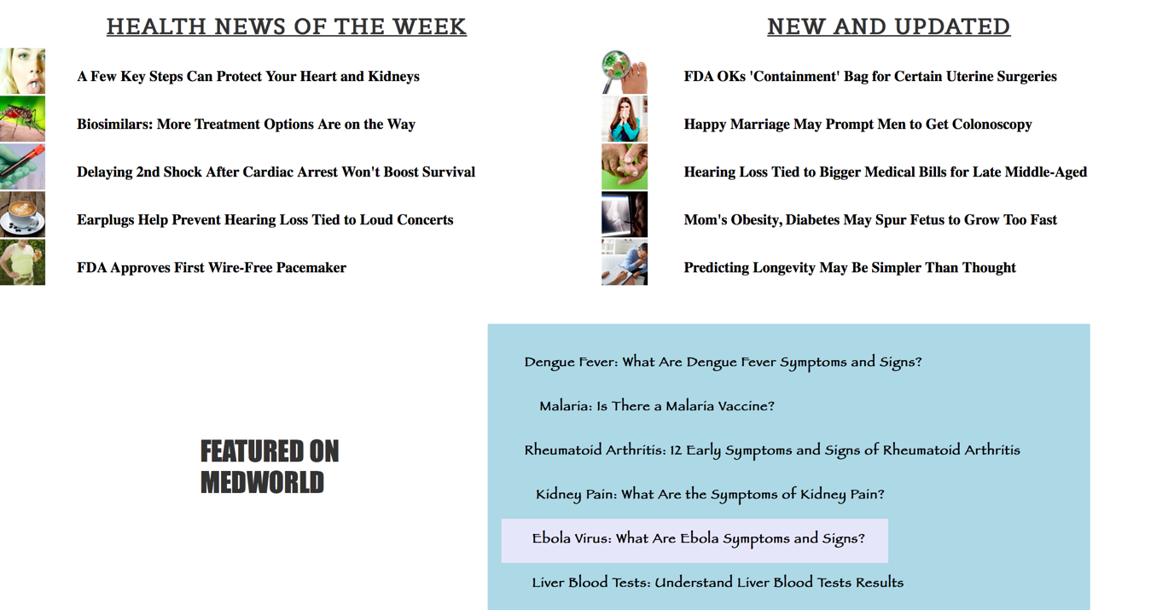

**HEALTHCARE MARKETTING**

This page allows you to

* Book an appointment , links you to practo, a database of doctors.
* Book a nurse
* Buy medices, links you to online portal of medicines



**HEALTHCARE MEDIA**

This page

* Decribes the ways to live a healthy life .
* Provides you with videos and photos of various postures and aasans. Videos of Swami Ramdev Ji, Acharya Bal Krisan

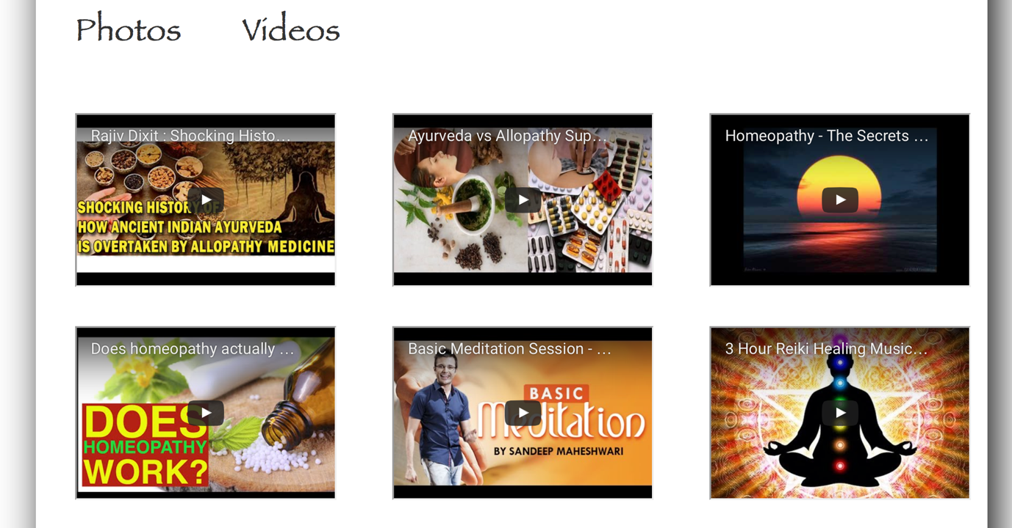

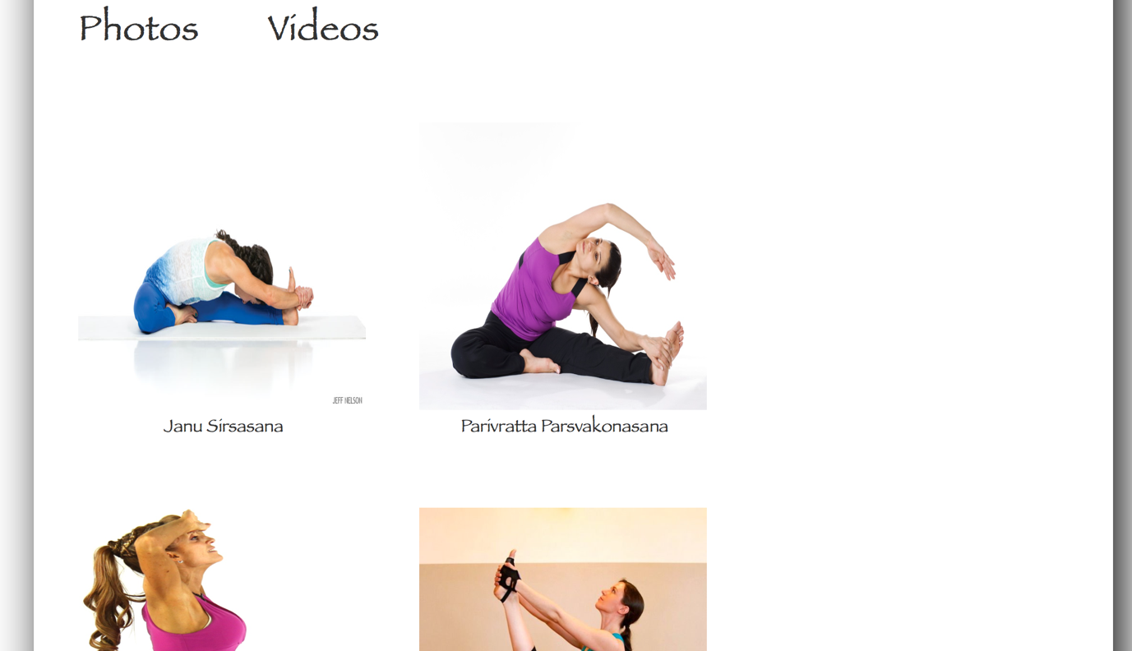

**A-Z Guide to disease**

This page

* is a guide not only to the patients but also to the doctors.
* Helps one recognise his/her symptoms , disease and the treatment

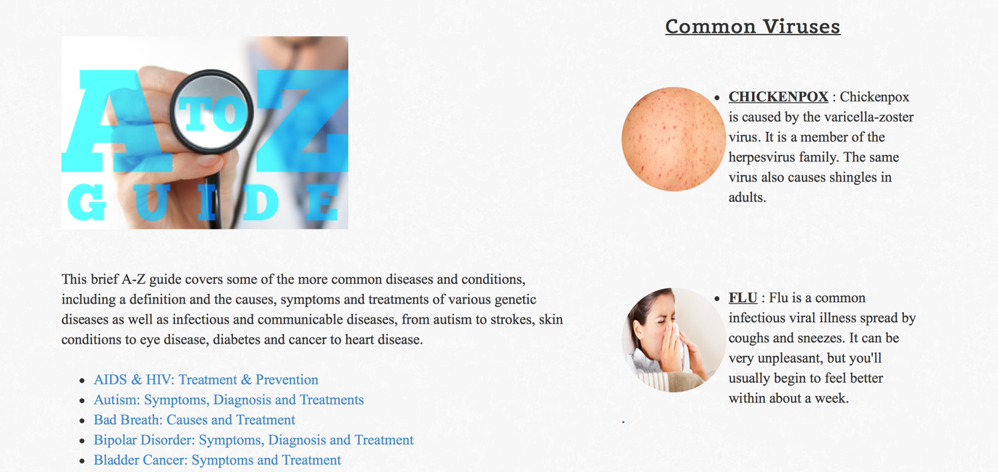

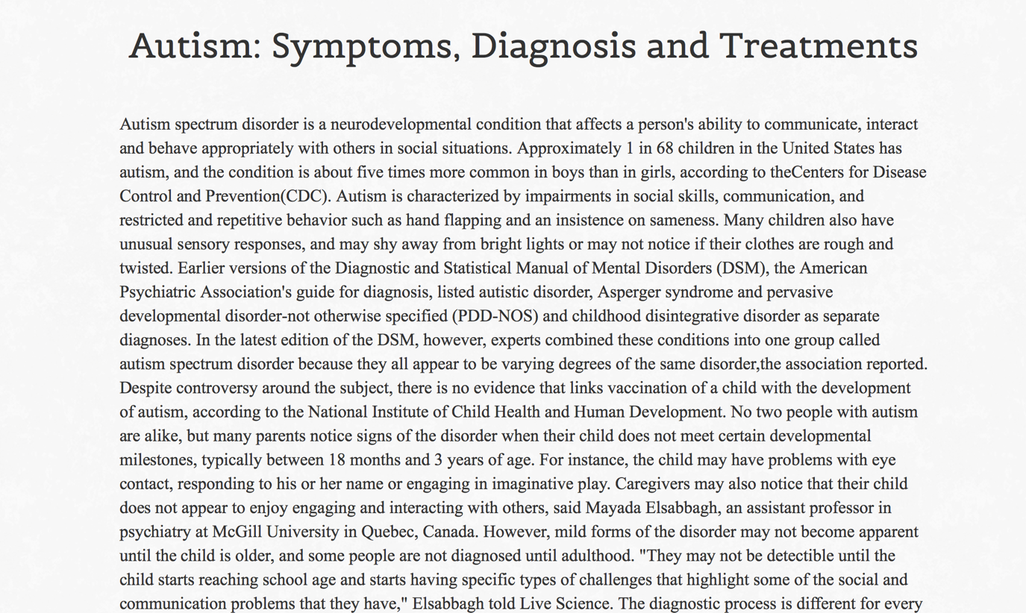

**VIDEO CHAT PAGE**

This page

* Allows you to view practo profiles of a number of doctors from different branches of medicine
* Allows you to video chat with the doctor

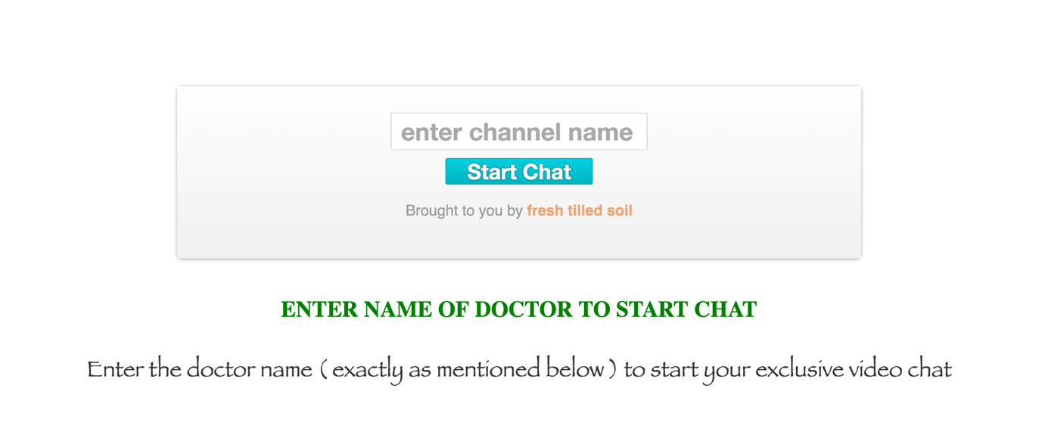

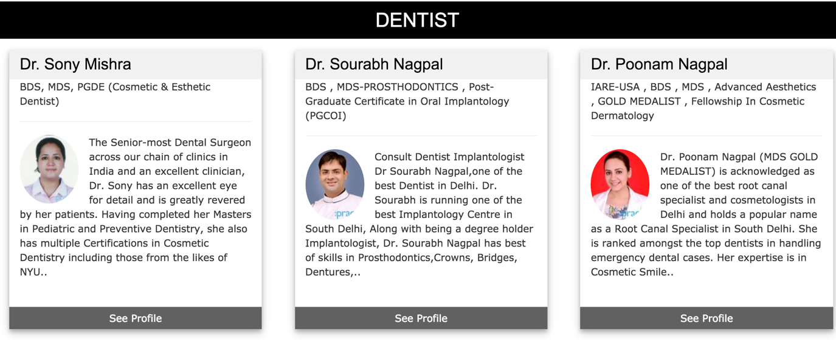

**ALLOPATHY PAGE**

*“Wherever the art of medicine is loved, there is also a love of medicine”—Hippocrates*

This page on allopathy

* provides information on what allopathy is
* how it is useful to cure diseases
* connects you with some of the best allopathy doctors.

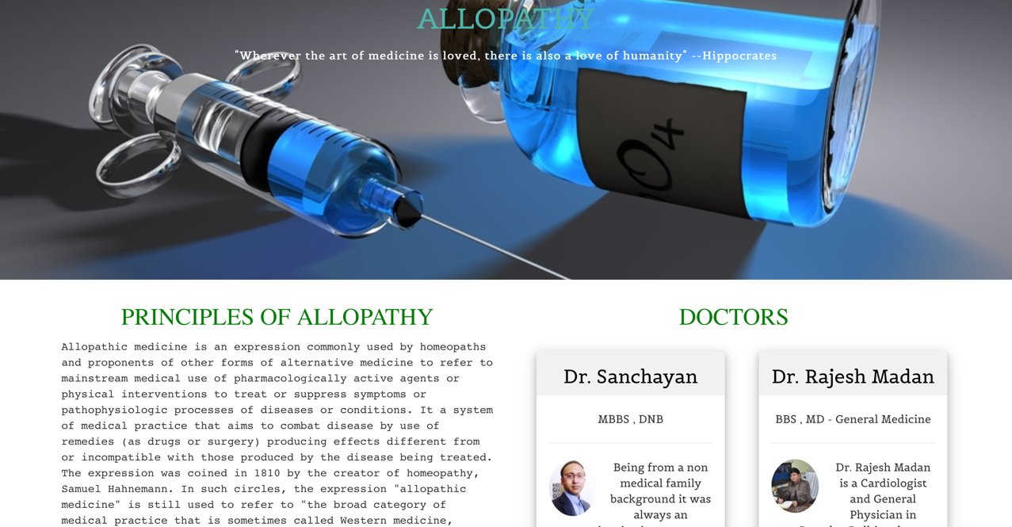

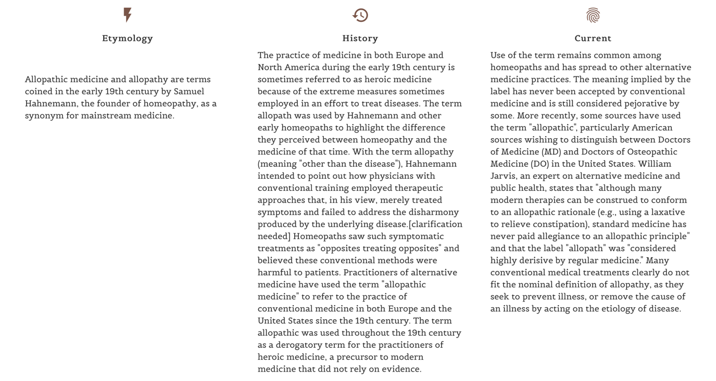

**HOMEOPATHY PAGE**

*“There have been two great revelations in my life: The first was bepop, the second was homeopathy.” ― Dizzy Gillespie*

This page on homeopathy

* connects user with some of the best homeopathy doctors around.
* helps you understand what homeopathy is
* tells you about its benefits

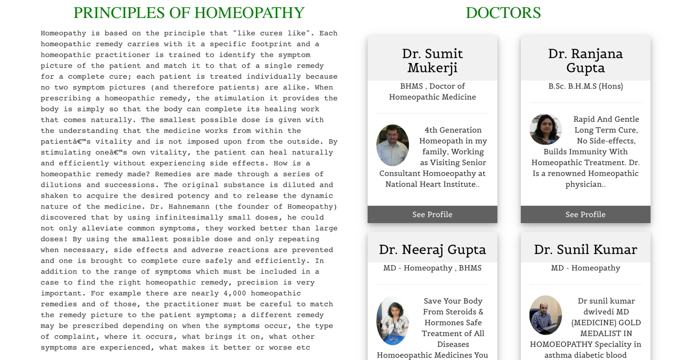

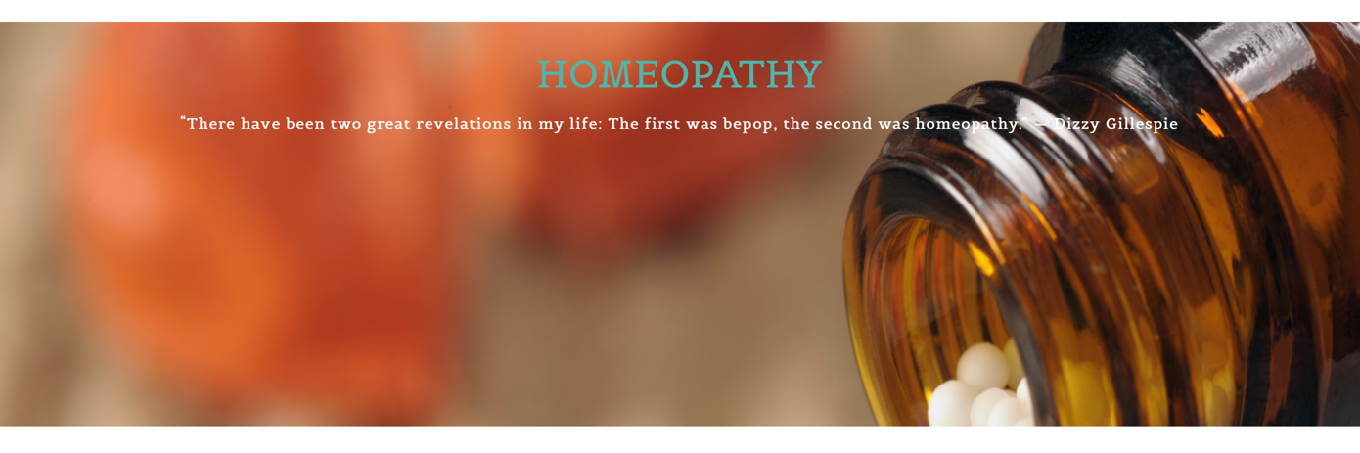

**AYURVEDA**

This page on Ayurveda

* gives introductory video tutorials on yoga
* provides you information on Ayurveda is and its benefits
* Provides profiles of Yoga gurus and Ayurveda doctors.

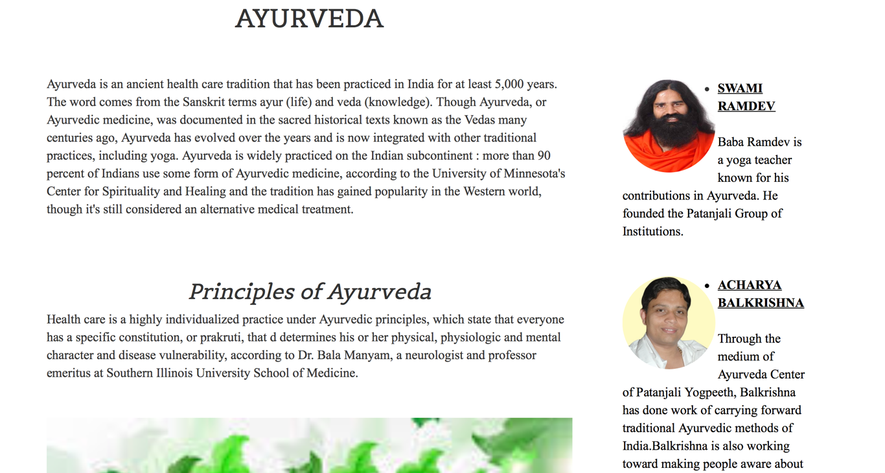

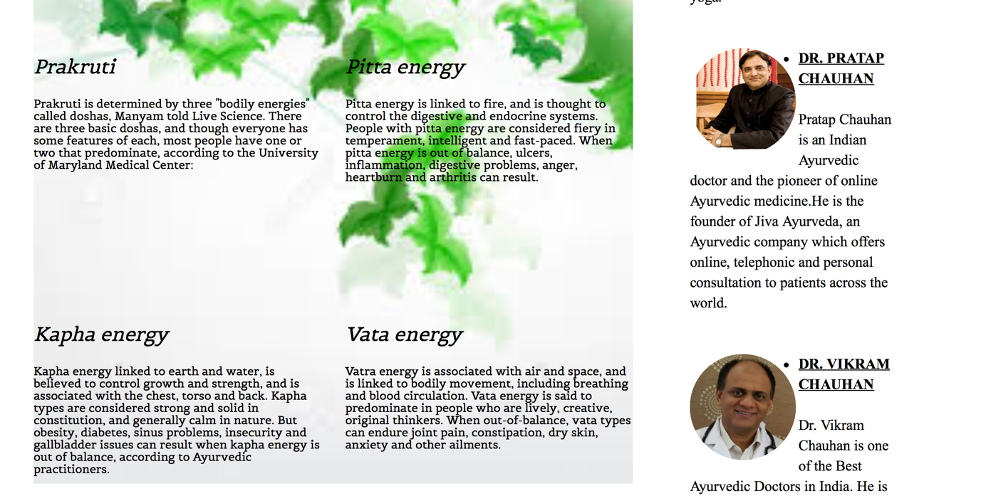

**ABOUT US**

This page on About Us

* Gives users a brief of what medworld is
* Provides contact information of out team

